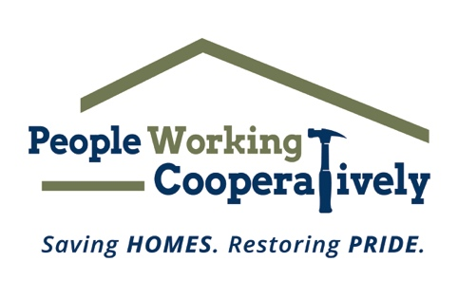
FOR IMMEDIATE RELEASE
Media Contact: Katie Forcade, Scooter Media
571-266-2878 | Katie@scootermediaco.com

Link to 2023 Photos
Photo Credit: People Working Cooperatively

Volunteers Needed for People Working Cooperatively’s Prepare Affair
Help neighbors in need by raking leaves, cleaning gutters to prepare homes for winter

CINCINNATI (Oct. 11, 2024) – A rake and gloves are all it takes to make a difference for your neighbors in need as we inch closer to the holiday season and winter months. People Working Cooperatively’s (PWC) annual fall volunteer event, Prepare Affair, is coming up in November for those looking to make a difference!

Throughout the month of November, volunteers will provide winter preparation services to help low-income, elderly, and disabled homeowners prepare their homes for the winter. Volunteers will help neighbors throughout Greater Cincinnati and Northern Kentucky by joining forces with friends, co-workers, church groups, and family members to create their own crew, or signing up as individuals to join an existing team. Last year, 1,700 volunteers came together to help serve 700 homes in the community.

“Prepare Affair is such an inspiring event, because it brings together thousands of local volunteers who just want to make a difference for their neighbors in need,” said Jock Pitts, President of People Working Cooperatively. “To you or I, raking leaves or cleaning gutters may seem like a small thing. But to a homeowner who can’t physically get outside and complete those maintenance tasks in preparation for winter, it’s an incredible gift. Our staff and volunteers are able to improve the appearance of these homes and yards, help restore pride for these homeowners, and make a positive and significant impact in our community.”

Prepare Affair projects primarily include raking leaves and cleaning gutters, and this event is open to volunteers of all ages and ability levels. PWC will be celebrating Prepare Affair on Saturday, Nov. 16, but volunteers are invited to schedule their service on any day in November that works best for them.

Registration is available online at pwchomerepairs.org/prepare-affair. For more information, contact Brian McLaughlin, PWC Volunteer Program Manager, at 513-351-7921.

Prepare Affair is presented by The City of Cincinnati.

# # #

About People Working Cooperatively
Incorporated in 1975, People Working Cooperatively (PWC) is a non-profit organization serving low-income, elderly, and disabled homeowners in 20 counties of southwest Ohio, Dayton, northern Kentucky and southeast Indiana. For 49 years, PWC has strengthened communities by providing professional, critical home repair, weatherization, and modification services to help residents stay safely in their homes. PWC’s staff of licensed, trained employees and dedicated corps of volunteers assist nearly 6,000 individuals in more than 3,500 homes each year. For more information, visit pwchomerepairs.org or call (513) 351-7921.

