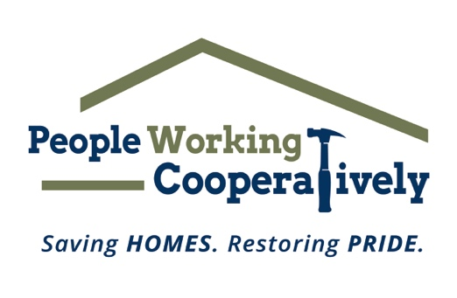
FOR IMMEDIATE RELEASE
Media Contact: Katie Forcade, Scooter Media
(571) 266-2878| katie@scootermediaco.com

.
Click here for photos/videos from last year’s Repair Affair.
Photos courtesy of People Working Cooperatively.

Join People Working Cooperatively in making a difference: Volunteers needed for Repair Affair this June
Annual volunteer event will provide home maintenance services for neighbors in need

CINCINNATI (May 1, 2024) – People Working Cooperatively (PWC), a nonprofit that provides critical home repair, weatherization, and accessibility modification services for low-income homeowners throughout Greater Cincinnati, is seeking volunteers for its Repair Affair in June.

Repair Affair is PWC’s annual volunteer event that provides low-income seniors, people with disabilities and veterans with home repairs and maintenance tasks they need to keep their home safe. During last year’s Repair Affair, more than 450 volunteers donated 1,850 hours of their time painting exteriors, repairing walkways, landscaping and more at 50 households throughout the region.

“If you’re looking for an opportunity to get outdoors and spend a morning doing something good in your community, Repair Affair is the answer,” Brian McLaughlin, PWC Volunteer Program Manager, said. “Neighbors in many communities here in Greater Cincinnati are on a waiting list for services they may not be able to manage on their own, and every year we see hundreds of volunteers step up to help us tackle that waiting list. While we are always in need of individuals and groups with home repair skills, we can match any skill level to a job. So whether you’re comfortable handling a jackhammer or a paintbrush, we have a deserving client that can use your skills.”

The main participation date for Repair Affair is Saturday, June 8, which includes a post-event celebration with free food and fun for all volunteers back at PWC’s headquarters in Bond Hill. However, volunteer groups can sign up to participate for any day in June that works best for them.

PWC will provide participants with all materials and handle debris disposal. Volunteers are asked to commit to at least four hours of service and will be matched with a project that fits the skills and preferences of their group.

Common projects completed as part of Repair Affair include:

- Installing handrails
- Repairing drywall
- Fixing leaky plumbing
- Repairing damaged walkways and steps
- Performing other home maintenance for the clients

Many of PWC’s clients are elderly, veterans, single parents or grandparents raising children, and individuals with disabilities living on a fixed income. The organization is often the only resource for these underserved community members, and it is committed to providing professional expertise and services to help these residents remain living independently, safely and healthily in their homes.

Volunteers can register online at pwchomerepairs.org/repair-affair or contact Brian McLaughlin, PWC’s Volunteer Program Manager, at mclaughlinb@pwchomerepairs.org.

Thank you to our 2024 sponsors: Presenting Sponsor City of Cincinnati; Cornerstone Partner BSI Engineering; and Supporting Sponsors Danis Construction and Prus Construction.

# # #

About People Working Cooperatively
Incorporated in 1975, People Working Cooperatively (PWC) is a non-profit organization serving low-income, elderly, and disabled homeowners in 20 counties of southwest Ohio, Dayton, northern Kentucky and southeast Indiana. For 49 years, PWC has strengthened communities by providing professional, critical home repair, weatherization, and modification services to help residents stay safely in their homes. PWC’s staff of licensed, trained employees and dedicated corps of volunteers assist nearly 6,000 individuals in more than 3,500 homes each year. For more information, visit pwchomerepairs.org or call (513) 351-7921.

