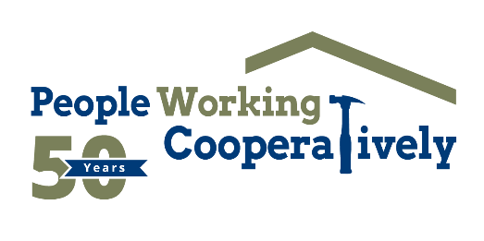

FOR IMMEDIATE RELEASE

**Media Contact:** Katie Forcade, Scooter Media

571-266-2878 | [katie@scootermediaco.com](mailto:katie@scootermediaco.com)

**People Working Cooperatively awarded nearly $260,000 in funding to provide critical support to underserved residents**

**CINCINNATI (Feb. 10, 2025)** – [People Working Cooperatively (PWC)](http://www.pwchomerepairs.org/), a nonprofit that provides professional critical home repair, weatherization, and accessibility modification services for neighbors living on low or fixed incomes in communities throughout Greater Cincinnati, has announced that it received 11 grants in the fourth quarter of 2024 to support its mission.

The grants include:

* **Butler Helping Hands** awarded $5,000 for modification projects in Northern Kentucky.
* **Centerpoint Energy Foundation** awarded $25,000 for repairs and modifications to help clients in the Dayton area.
* **Cleveland Cliffs Foundation** awarded $20,000 for the Repairs and Modifications Program, which was matched dollar-for-dollar by The Farmer Family Foundation and its Trustees.
* **Colerain Township** awarded $1,500 for Prepare Affair and Colerain Give Back Day, which are volunteer service days that help PWC attend to the waitlist of people qualifying for assistance.
* **Good Shepherd Catholic Church** awarded $6,000 toward volunteer events.
* **Huntington Charitable Foundation** awarded $10,000 for repairs and modifications.
* **Macy’s** awarded $13,000 for the Modifications for Mobility program, which helps improve daily mobility and independence for some of PWC’s most vulnerable clients by helping with modification projects such as chair/stair lifts, accessibility ramps, bathroom modifications, and more.
* **The P&G Fund of the Greater Cincinnati Foundation** awarded $50,000 for repairs and modifications.
* **Robert and Adele Schiff Family Foundation** awarded $100,000 for home repairs in collaboration with the Community Learning Center Institute.
* **Rumpke** awarded $1,500 for volunteer events.
* **The Sutphin Family Foundation** awarded $27,150 for accessibility improvements to PWC’s headquarters and purchase of tools.

“These wonderful organizations and their financial support play a crucial role in PWC’s mission of repairing homes and restoring pride for our underserved community members,” said Chris Owens, Vice President of Development for PWC. "The grants we receive allow us to help more people by expanding our home repair and modification services for those who need them most—veterans, single parents, grandparents raising grandchildren, and individuals with disabilities. With this funding, we can make a real, lasting impact for our neighbors who often don’t have the means to make these repairs themselves."

To learn more about People Working Cooperatively and who is eligible for services, visit [pwchomerepairs.org](http://www.pwchomerepairs.org/) or call (513) 351-7921.

# # #

**About People Working Cooperatively**  
*Incorporated in 1975, People Working Cooperatively (PWC) is a non-profit organization serving low-income, elderly, and disabled homeowners in 20 counties of southwest Ohio, Dayton, northern Kentucky and southeast Indiana. For 50 years, PWC has strengthened communities by providing professional, critical home repair, weatherization, and modification services to help residents stay safely in their homes. PWC’s staff of licensed, trained employees and dedicated corps of volunteers assist nearly 6,000 individuals in more than 3,500 homes each year. For more information, visit*[*pwchomerepairs.org*](http://pwchomerepairs.org/)*or call (513) 351-7921.*