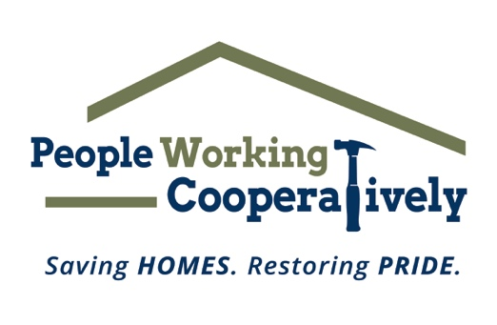

FOR IMMEDIATE RELEASE
Media Contact: Katie Forcade, Scooter Media
571-266-2878 | katie@scootermediaco.com

People Working Cooperatively secures funding support for critical home services
Grant funding enables nonprofit to deliver repair and modification services for safer, healthier homes for underserved residents

CINCINNATI (Nov. 20, 2024) – People Working Cooperatively (PWC), a nonprofit that provides professional critical home repair, weatherization, and accessibility modification services for low-income neighbors in communities throughout Greater Cincinnati, has announced that it is the recipient of nine grants, six of which will be matched dollar-for-dollar by the Farmer Family Foundation, to help continue its mission.

The grants include:
- Butler Foundation Helping Hands Program awarded $2,500 in project support.
- CenterPoint Energy Foundation awarded $25,000 for home repairs and modifications in the Greater Dayton area.
- DeWalt Grow the Trades awarded an in-kind donation of tools worth $10,000.
- Farmer Family Foundation Matching Grants:
These organizations and foundations provided grants that will be matched dollar-for-dollar by the Farmer Family Foundation and its Trustees as part of the $1 million challenge grant the Foundation awarded PWC earlier this year.
  - Barry F. Smith Fund of the Cambridge Charitable Foundation awarded $27,500
  - The Cleveland-Cliffs Foundation awarded $20,000
  - Millstone Fund awarded $50,000
  - Reynolds and Reynolds Associate Foundation awarded $1,500
  - Rolfes Family Fund at Horizon Community Funds of Northern Kentucky awarded $25,000
  - Thornwell Family Foundation awarded $25,000

“I want to thank all of these wonderful organizations for their generous support toward PWC’s mission of restoring homes and restoring pride for our underserved community members,” said Chris Owens, Vice President of Development for PWC. “All the grants we receive, including those matched by the Farmer Family Foundation, enable us to expand our vital home repair and modification services for neighbors in need who don’t have the resources to make these repairs on their own. This includes veterans, single parents, grandparents raising grandchildren, and individuals with disabilities. This funding allows us to make a meaningful and lasting impact in our community.”

To learn more about People Working Cooperatively and who is eligible for services, visit pwchomerepairs.org or call (513) 351-7921.

# # #

About People Working Cooperatively
Incorporated in 1975, People Working Cooperatively (PWC) is a non-profit organization serving low-income, elderly, and disabled homeowners in 20 counties of southwest Ohio, Dayton, northern Kentucky and southeast Indiana. For 49 years, PWC has strengthened communities by providing professional, critical home repair, weatherization, and modification services to help residents stay safely in their homes. PWC’s staff of licensed, trained employees and dedicated corps of volunteers assist nearly 6,000 individuals in more than 3,500 homes each year. For more information, visit pwchomerepairs.org or call (513) 351-7921.

